**Order Book Assignment Delivery Report:**

**Summary:**

* **Used Angular 10, Python 3.6, Pandas and Flask**
* **End to end working except persisting orders from Angular form submission**
* **Testcases are covered for backend only**
* **Data persistence using HD5 files.**

**Screen Shots:**

**Order-Book Activity Flow**

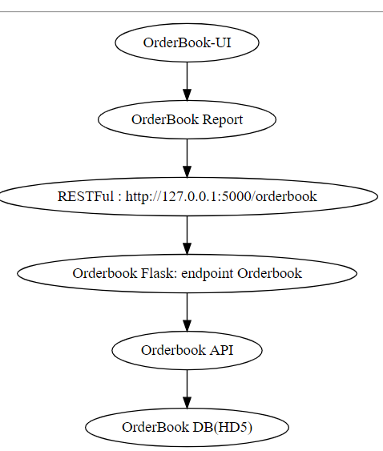

|  |  |
| --- | --- |
| **Order-Book Backend REST API Data** | **Report Order Book Angular** |
|  |  |
| **Getbestbidask REST API Data** | **Angular Based getBestBidAsk** |
|  |  |

**Add Order details (not working. In complete)**

